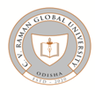
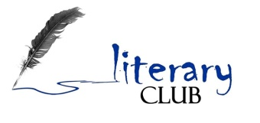
LITERARY CLUB
DEPARTMENT OF HSS
C. V. RAMAN GLOBAL UNIVERSITY

NOTICE DATE: 9.03.2021

A talk will be given by Prof. Sunil Sarangi, Former Director of NIT, Rourkela and currently Advisor, CGU on India’s Freedom Struggle. It will be a part of celebration of “Azadi ka Amrut Mahotsav” as proposed by AICTE, New Delhi regarding the year long celebration of India’s 75 years of Independence.
All the faculty and students of CGU are hereby invited to attend the talk.
Date- 12 March 2021
Time- 2.30pm
Link- https://meet.google.com/kiq-mvqe-wtt

Chairperson
Literary Club, CGU

